For HDFS-Access we need to

* Copy files using rsync from local to the master node
  + Need to get the IP-Address of the master node  
    🡪 can we get this from dcos?  
    🡪 Manual for ssh says “take it from the web interface”
* Copy files using rsync from the master node to a slave node
* Execute a hdfs command on the slave node

# Get IP of master node

## Option 1: use REST Service

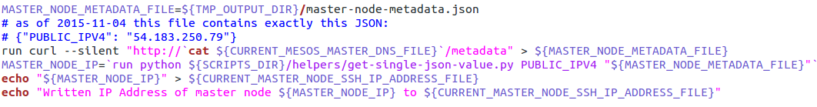

## Option 2: try dcos command

Goal: Get IP-Address “54.215.208.81”

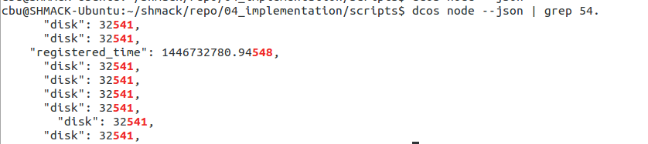

* Dcos node not usable

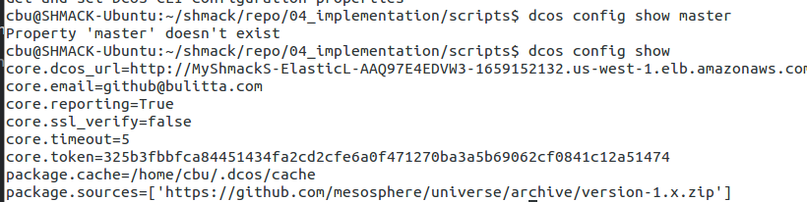

* Dcos config also not usable

# SSH Into master node

## Option 1:

dcos node ssh --master-proxy --master

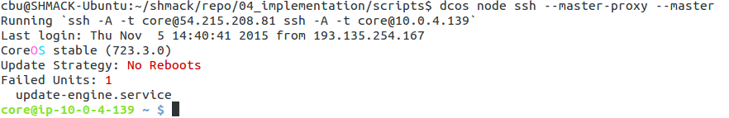

## Option 2:

./ssh-into-dcos-master.sh

